

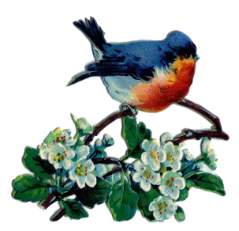


April/May/June 2026
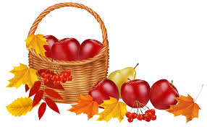

Our ministry vision for the Virginia Annual Conference is “to be disciples of Jesus Christ who are lifelong learners, who influence others to serve.”

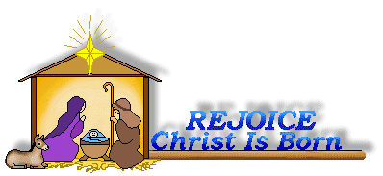

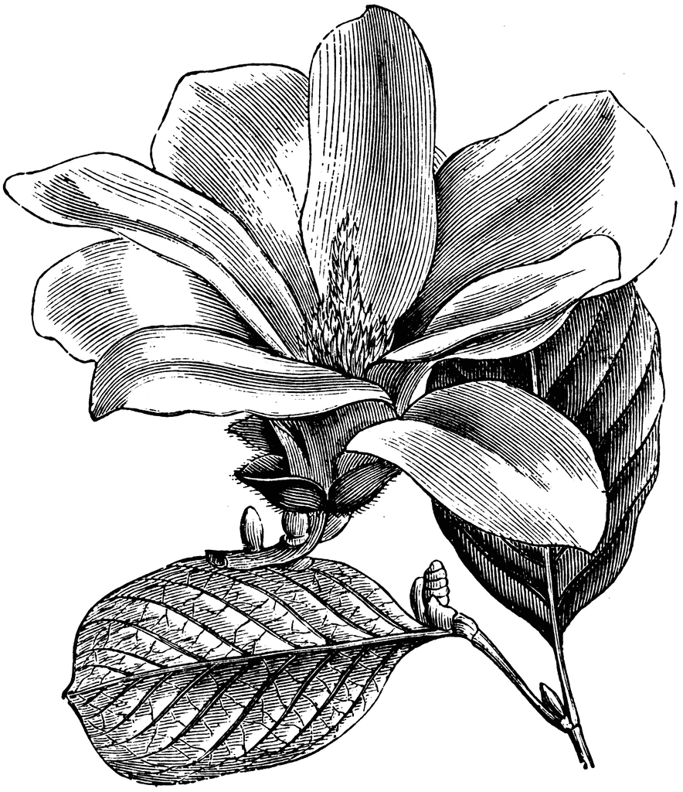


From Pastor Adam

“How Does Your Garden Grow?”

“For everything there is a season...a time to plant, and a time to pluck up what is planted.”
Ecclesiastes 3:2

“Other seeds fell on good soil and brought forth grain, some a hundredfold, some sixty, some thirty. Let anyone with ears listen.” Matthew 13:8-9

“I planted, Apollos watered, but God gave the growth. So neither the one who plants nor the one who waters is anything, but only God who gives the growth. The one who plants and the one who waters have one purpose, and each will receive wages according to their own labor. For we are God’s coworkers, working together; you are God’s field, God’s building.” 1 Corinthians 3:6-9

This is the season for gardening! As soon as the weather begins to warm, it’s time to put new plants into the ground and to begin the season of nurturing the plants that have already taken root. My wife, Jeanmarie, is an avid gardener. Yet, I’m still learning my way around the many lovely things that inhabit our flower garden. Gardening requires attention and discipline – watering, weeding, tending – and yet, the miracle of the growth comes from elsewhere – it comes from God. This is one of the things that makes gardening such a splendid enterprise. It requires our investment and still the growth is nothing less than a miracle. The metaphors surrounding planting and reaping, gardens and gardening are everywhere in Scripture. And I suppose this comes from the simple fact that planted things give us life. What’s the old saying? No farmers, no food. Crops and farming were as essential to ancient peoples as they are to us today. One can see why “gardening language” made its way into the Bible. The language of the garden or the field can represent many things in Scripture – the kingdom of God, the church, the community, life, the world, the soul. What’s clear is that we are to be invested in such things just as a careful gardener is invested in their garden. So as this season of spring blends into summer, we do well to ask – What good things might we plant in the metaphorical gardens around us? What good things might we plant in our neighborhoods? What gifts and talents might I invest in the life of my church, my family, my workplace? What spiritual practices (daily prayer, scripture reading, devotional literature, service) might I plant in myself to foster the garden of my soul? Are there weedy habits that need to be plucked out of my life? In the garden of life and in the garden of the world – it is always right to ask ourselves (in the words of “Mary, Mary, Quite Contrary”): “How Does Your Garden Grow?” Friends, may you flourish and bloom in this season and in every season! ~God bless you each and every one, Adam




Circle News
The Merry Marthas Circle will meet on April 16th, May 21st, and June 18th, at 10:30 a.m., at church. We will pack Kits for Conference in May. Each meeting will be followed by lunch at Charley's. If anyone has a program or devotion you'd like to present please let me know. ~Judy Robertson

The Wesleyan Group will meet on Monday, April 20th, at 7:00 p.m., at the home of Mary Walker. We will pack Kits for Conference. May’s meeting will be announced. And on June 8th at the home of Jane White. ~Ann Robbins


The choir will be singing on Sundays, April 12 & 19. We will be rehearsing at 10:00 a.m. May & June will be announced later. We will sing familiar hymns so come join us! ~Sharon Mayhew, Director of Music


Food Cart: April, May, June
Canned Chunky Soups & Canned Fruit/Vegetables (Pull tops)
No “baked goods”! Place donations in the grocery cart, located in the Commons.

Friends Who Care

All participants please fill out the Care Sheet placed in the Commons or email your reports of visits and phone calls to mx55566@gmail.com. On your report please note the month and year, names of those visited (or called) and the number of times visited or called. We express our appreciation to all the volunteers who participate in this ministry of compassion. If you would like to volunteer contact Scottie Nuckols. A total of 8 phone calls and 4 visits were made in January-March. Thank you!


Missions Report
We collected 94lbs of food items and 7lbs of hygiene items last quarter. For April/May/June food cart we will collect Chunky Soups, Fruit/Vegetable Canned goods. ~Thank you, Linda Jessen & Mission Committee


1 Pat Short
2 Nancy Lee
Emily V.
Fernandez
3 Michael McGlothlin
6 Kirsten Bell
Tim Crist
Dennis Tolley
7 Kenny Busic
Cheryl Powell
9 Owen Stinnette
Jeremey
VandeBogart
11 Landen Glass
12 Camden Mason
14 Wade Ware
16 Burton Brooks
Terry Palazzi
Anne-Elaine Tiller
17 Suzanne
Marshall
Blake Phillips
18 Sharon
Rickmon
19 Connie Yost
20 Erin Ecklund
21 Steven Kinzer
22 C.O. Bell
25 Frankie
Hardwick
28 Jacqueline Busic
Cheryl Thomas
29 Wes Robbins
Ricky Smith
31 Robert Baunach

2022
March 2022
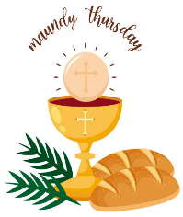
Mark your calendar…
Join us for Maundy Thursday worship service on Thursday, April 2, 2026, at 6:00 p.m. Holy Communion will be served.



GOOD NEWS will be published quarterly. Pick up your copy in the Commons or watch for it on our website: www.chestnuthillumc.net.

Our Church Financial Picture
Through the end of March 2026
General Operating Funds:
Needed to meet our 2026 Budget $ 181,480.00
Needed to meet our budget to date $ 45,350.00
Actual receipts to date $ 30,739.00
Shortage to meet budget to date $ 12,611.00
Actual expenditures to date $ 13,300.00
Shortage to meet expenses to date $ 689.00
Special Offerings* (not budgeted):
Received to date $ 525.00
Dispersed to date $ 0.00
*Christmas, Easter, Annual Conference,
World Communion, etc.
Thank you for your generosity.
~Those Who Serve ~
APRIL GREETERS
April 5 ~ Ann Robbins
April 12 ~ Jane White
April 19 ~ Mary Walker
April 26 ~ Betty Taylor

MAY GREETERS
May 3 ~ Dan Robertson
May 10 ~ Ann Robbins
May 17 ~ Judy Robertson
May 24 ~ Betty Taylor
May 31 ~ Mary Walker
JUNE GREETERS
June 7 ~ Maggie Musgrove
June 14 ~ Jane White
June 21 ~ Judy Robertson
June 28 ~ Mary Walker
WORSHIP LEADERS
April 19 ~Judy Robertson
May 17 ~Linda Jessen
June 21 ~Ann Robbins


Birthdays…
June Birthdays
1 June 23 Alice Frank
Crickenberger 24 Jeanne Carter
2 Sandra Lane Lisa Stout
5 Erin Long 25 Paul Compton
Amanda White 26 Rebecca Cole
8 Vernelle Roupe 27 Joseph Palazzi
9 Ramona Akins Cliff Taylor
11 Alice Lovelace 30 Kane Dalton
12 Frances Unruh Katie Jessen
13 Kristy May
15 Dan Robertson
19 Suzanne Allen
Hannah Donald
20 Scottie Nuckols
21 Elizabeth
Candler
Chris Henson
Sue Norvelle

May Birthdays
1 Kim VandeBogart
4 Shaun VandeBogart
6 Tommy Mason
12 McKenna Mason
16 Rev. Elizabeth Ecklund
18 Jordan VandeBogart
20 Kennedy Ecklund
22 Carolyn Anders
23 Robbie Perrow
27 Susan Blunt
28 Robert Hicks
Kelly Mason
29 Tucker Cole
31 Dean Burgess

April Birthdays
1 Marable Southall-Vess
3 Tammy Cole
Nicholas Redford
Finn Tiller
6 Tamlyn Beiler
9 Michael Southall-Vess
10 Jeanmarie Martinko White
16 A. Ellen White
17 Dianne Johnson
22 David Cole
Laura White
24 Kelly Kinzer
27 Kim Stewart
Elizabeth Willis
28 Linda Collins
29 Carolyn Phelps

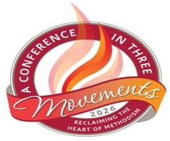
Virginia Annual Conference
Atlantic Union Bank Center, James Madison University
Harrisonburg, VA
June 17-20, 2026

Kits for Conference
Chestnut Hill will serve as drop off point, for collection of Kits, for churches on our District during the month of May.


GRADUATES
Graduation is upon us. Let the church office know if you, or a family member, will be graduating this year. You can call us at 239-8423 or email us at chestnuthillumc@comcast.net.

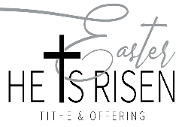
Easter Offering
Our goal to reach will be $6,000.00. Our Easter offering will go towards roof repair over office area. Envelopes are provided in the pew racks for the month of April.

Easter Sunrise Service
On Sunday, April 5 @ 7:00 a.m. @ Fort Hill Memorial Park (5196 Fort Avenue), Garden of Crucifixion (beside Mausoleum). In case of rain, we will use the Mausoleum. Bring your own portable chair. Sponsored by Lynchburg Area UM Churches. Participating congregations are invited to Fort Hill UMC for Easter Breakfast at 8:30 a.m. following the service. You may make a reservation and volunteer to bring food items by calling or emailing the church office (434-847-1251; secretary @
forthillumc.com). Please let us know you are coming by noon on Wednesday, April 1.


In Memorian
Charles William Moore
February 13, 2026
Linwood Eugene “Jimmy” Blunt
March 14, 2026

Thank you to Rev. Adam White and to my Chestnut Hill UMC Family for the prayers, love, cards, food, and concern shown to me, and my family, during this difficult time. My family and I are blessed to have you all! ~Love, Pat Moore and Family

Chestnut Hill United Methodist Church extends Christian love and sympathy to the family of Jane Crews and especially to her brother, Ed Compton. Mrs. Crews passed away on February 4, 2026.


Souper Bowl Sunday (Meals on Wheels)
We received $440.00 for Meals on Wheels. Thank you for your continued support of this ministry.


Gifts & Memorials
In Memory
George Jessen
Given by: Wilton & Kitty Burgess,
Dan & Judy Robertson,
Wes & Ann Robbins,
Diane, Richard, & Amanda Schweitzer,
Brenda Franklin, Angelia Page & Family,
The Beasley Family, Cliff & Betty Taylor
Loretta Mayhew
Given by: Wilton & Kitty Burgess, Dan & Judy Robertson, Frances Unruh,
Wes & Ann Robbins, Harriett Darst,
Thomas Leebrick, Ron & Ginny Bryant,
Mr. & Mrs. William N. Gray, Scottie Nuckols,
Cliff & Betty Taylor, Jay & Lisa Pearce
Barbara Blunt
Given By: Cliff & Betty Taylor
Charles Moore
Given by: Linda Jessen, Frances Unruh,
Wilton & Kitty Burgess
Jimmy Blunt
Given by: Frances Unruh, Bob Elium,
Robert & Mary Baney,
Kenneth & Christine Arthur



 Calendar of Events
Sundays—Sunday School, 9:30 a.m. ~ Worship Service, 10:30 a.m.
Fridays –Homeschool, 9:30 a.m. (School Year)
April
Wednesday, April 1 ~Homeschool Rehearsal, 11:00 a.m.
Thursday, April 2 ~Maundy Thursday Service, 6:00 p.m.
Friday, April 3 ~Homeschool/Theater Night, 9:30 a.m.
Saturday, April 4 ~Baby Shower, 2:00 p.m.
Monday, April 6 ~Church Office Closed
Sunday, April 12 ~Choir, 10:00 a.m.
Tuesday, April 14 ~Homeschool Game Night, 7:00 p.m.
Thursday, April 16 ~Merry Martha’s Circle, 10:30 a.m.
Friday, April 17 ~Homeschool, 9:30 a.m.
Monday, April 20 ~Wesleyan Group @ Walker Home,7:00 p.m.
Friday, April 24 ~Homeschool/Yearbook Party
Sunday, April 26 ~Choir, 10:00 a.m.
May
Friday, May 1 ~Homeschool/Set-Up, 9:30 a.m.
Saturday, May 2 ~Homeschool Festival of the Arts/Graduation, 12:00 p.m.
Monday, May 11 ~Wesleyan Group, 7:00 p.m.
Tuesday, May 12 ~Homeschool Game Night, 7:00 p.m.
Thursday, May 21 ~Merry Martha’s Circle, 10:30 a.m.
Monday, May 25 ~Memorial Day~Church Office Closed
June
Monday, June 8 ~Wesleyan Group @ Jane White’s Home, 7:00 p.m.
Tuesday, June 9 ~Homeschool Game Night, 7:00 p.m.
Wednesday, June 17-20 ~Virginia Annual Conference-Atlantic Union Bank Center
@James Madison University, Harrisonburg, VA
Thursday, June 18 ~Merry Martha’s Circle, 10:30 a.m.

Mother’s Day
Sunday, May 10, 2026

Father’s Day
Sunday, June 21, 2026

Chestnut Hill United
Methodist Church
4660 Fort Avenue, Lynchburg, VA 24502
Phone Number: 434-239-8423
E-mail: chestnuthillumc@comcast.net
On the web: www.chestnuthillumc.net

Church Office Hours
Monday-Thursday~9:00 am—3:30 pm
Friday~9:00 am-1:00 pm



DIRECTORY OF
CHESTNUT HILL UNITED METHODIST CHURCH
 | Sue Haupert-Johnson | Richmond Area Resident Bishop
 | Rev. Dr. Sarah Calvert | Mountain View District Superintendent
 | Adam White | Minister
 | Monica Campbell | Administrative Assistant
 | Sharon Mayhew | Director of Music Ministry
 | Judy Martin | Bookkeeper
 | Judy Robertson | Lay Leader
 | Elizabeth Nichols | Missionary in Henry County

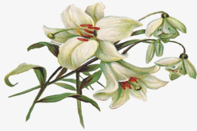

January 2022
2022
April 2022
April 2022
March 2022

